REPORT ON PUBLIC CONSULTATIONS

As part of the preparation of the World Bank Project "Multiphase Programmatic Approach to the Development of the Gas Sector in the Republic of Serbia - Phase 1: Strategic Gas Infrastructure and Institutional Strengthening Project", and in accordance with the World Bank standards in the field of environmental and social protection, the following documents were prepared: Scoping Report (SR), Resettlement Policy Framework (RPF), Stakeholder Engagement Plan (SEP), and Environmental and Social Commitment Plan (ESCP).
In accordance with the World Bank Environmental and Social Standard (ESS10) - Stakeholder Engagement and Information Disclosure, as part of the preparation of the Strategic Gas Infrastructure and Institutional Strengthening Project (SGIIS), implemented with World Bank support, the Ministry of Mining and Energy conducted public consultations with relevant stakeholders concerning the objectives, indicative project implementation area, and the social and environmental aspects of the project.
Starting from 27 July 2026, the Ministry of Mining and Energy (MоME) disclosed the draft SR, RPF, SEP and ESCP documents on its website and issued an invitation to relevant stakeholders to participate in public consultations on these project documents.
The SR, RPF, SEP and ESCP documents, as well as the invitation to public consultations, were published on the following websites:
- Ministry of Mining and Energy:
https://www.mre.gov.rs/tekst/16891/-visefazni-programski-pristup-razvoju-gasnog-sektora-u-republici-srbiji-faza-1-projekat-strateske-gasne-infrastrukture-i-institucionalnog-jacanja.php
- Municipality of Aleksinac:
https://aleksinac.org/index.php/2026-07-28-05-54-39
- City of Nis:
https://www.ni.rs/obavestenje-o-javnim-konsultacijama-notice-on-public-consultations/
- Municipality of Cicevac: https://www.cicevac.rs/%D0%9E%D0%91%D0%90%D0%92%D0%95%D0%A8%D0%A2%D0%95%D0%8A%D0%90/315
- Municipality of Razanj:
https://razanj.ls.gov.rs/актуелности/јавни-позиви-и-конкурси/јавни-огласи/обавештење-о-јавним-консултацијама-notice-on-public-consultations/https://razanj.ls.gov.rs/aktuelnosti/javni-pozivi-i-konkursi/javni-oglasi/obavestenje-o-javnim-konsultacijama-notice-on-public-consultations/

The invitation to public consultations was also published in the daily newspaper Politika on 22 August 2026.

Figure 1. Invitation to public consultations, daily newspaper Politika
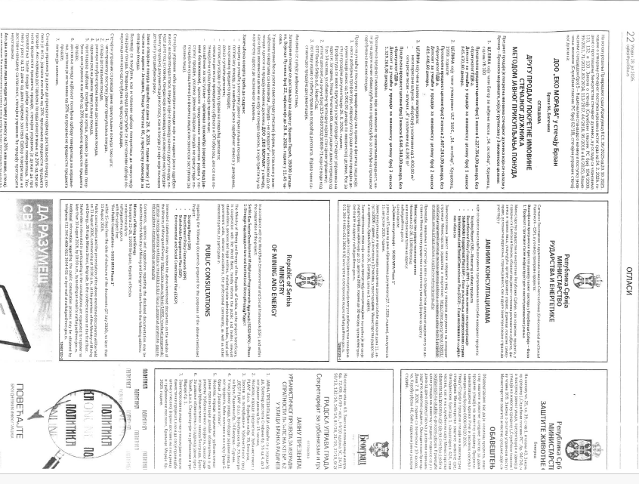

Figure 2. Website of the Ministry of Mining and Energy: invitation to public consultations and disclosed documents of the Ministry of Mining and Energy in Serbian and English
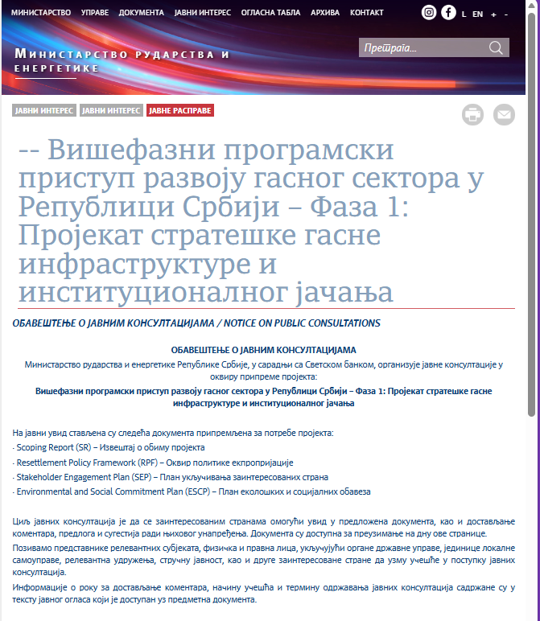
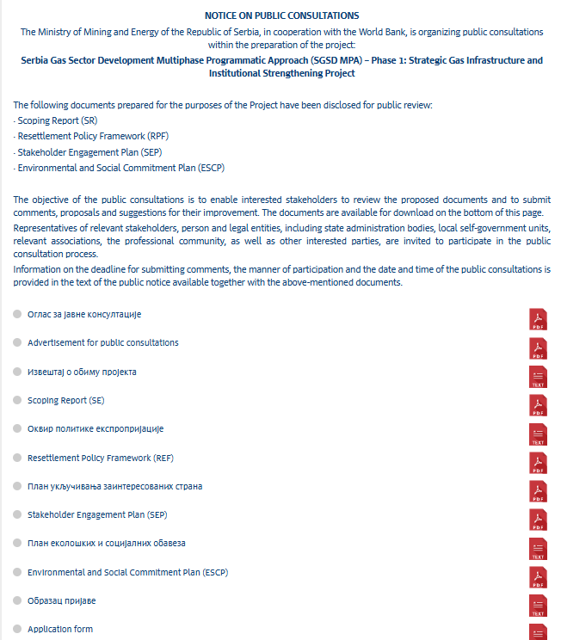
Public consultations and the presentation of the above documents were held in Belgrade on 11 August, in Aleksinac and Niš on 12 August, and in Ćićevac and Ražanj on 13 August 2026.
At all consultations held, Sasa Kokovic, Acting Assistant Minister of Mining and Energy, presented and provided basic information on the Strategic Gas Infrastructure and Institutional Strengthening Project.
He presented the project for the construction of the first section of the Niš - Velika Plana high-pressure gas pipeline, approximately 62 km long.
The objective of the project is to remove existing bottlenecks in the transmission system and to increase the security, reliability and resilience of gas supply in Serbia.
The main environmental and social risks were presented:
- impacts on watercourses,
- biodiversity and natural habitats,
- temporary and permanent land acquisition,
- loss of crops and income,
- health and safety of the local population,
- protection of cultural heritage.
The World Bank standards and the national legal framework applicable to the project were explained. Risk management instruments such as ESIA, ESMP, ESCP, SEP, GRM, RPF and RAP were presented. Emphasis was placed on transparency of the process, stakeholder engagement, and mechanisms for submitting comments and grievances.
The new gas pipeline should be technically adapted to future requirements, including the possibility of accepting hydrogen in line with European development trends.
It is expected that most questions and requests will relate to land expropriation, loss of crops, and compensation to owners and users of land plots.
The need to resolve property and legal matters and restitution issues along the existing route was particularly emphasized. The importance of a transparent grievance mechanism and monitoring of all stakeholder comments was also underlined.
Figure 3. Presentation of the Program for the Development of the Serbian Gas Sector

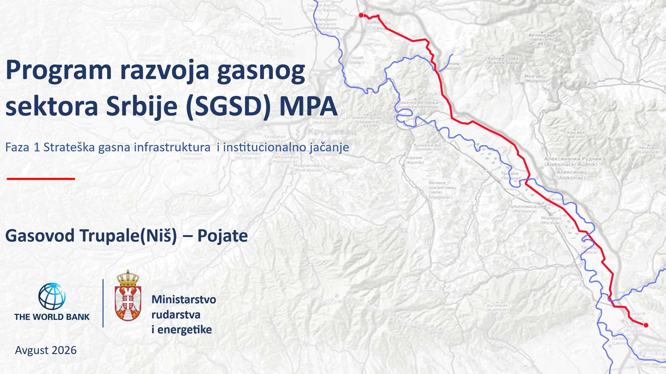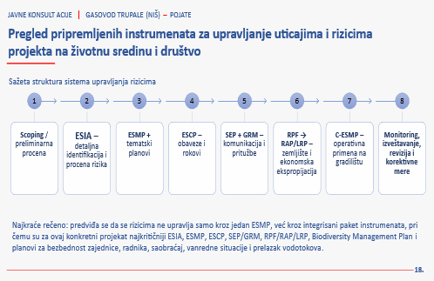
Belgrade, 11 August 2026
Public consultations and presentation of the draft SR, RPF, SEP and ESCP documents to stakeholders were held in Belgrade on 11 August 2026, at the premises of the Ministry of Mining and Energy, Kralja Milana 36, Belgrade, first-floor meeting room, starting at 10:00.
The meeting was attended by representatives of the Ministry of Mining and Energy, the Energy Agency of the Republic of Serbia, the Chamber of Commerce and Industry of Serbia, and other stakeholders.
The public consultations in the form of a round table started as planned at 10:00.
A total of 23 participants attended the public consultations:
List of participants present, Belgrade, 11 August 2026
No. | Name and surname | Institution
1. | Saša Koković | MоME
2. | Dejana Milovanović | AERS
3. | Branka Tubin Mitrović | AERS
4. | Borislav Rožić | Transportgas Srbija
5. | Dušan Krivokapić | Gas Infrastructure
6. | Vladimir Likić | PE Srbijagas
7. | Antonela Solujić | Chamber of Commerce and Industry of Serbia
8. | Marija Lazarević | MPSV-RDV
9. | Ana Raonić | MоME
10. | Danijela Vuković | MоME
11. | Grozdana Tomasović | MоME
12. | Doushka Negre | MоME
13. | Vukašin Mladjenović | MоME
14. | Vera Slijepčević | MоME
15. | Branko Djaković | MоME
16. | Jasna Savanović | MоME
17. | Milana Ilić | MоME
18. | Uros Djurdjević | MоME
19. | Snežana Ristić | MоME
20. | Natalija Luković | MоME
21. | Tatjana Radukić | MоME
22. | Aleksandar Zlatković | MоME
23. | Natasa Djokić | Consultant (online)

The public consultations were concluded at 11:30 a.m.
Questions and answers:

Borislav Rozic, Head of the Technical Affairs Sector of the transmission system operator Transportgas Srbija
He supported the presentation and highlighted the importance of the project, after which he presented several observations and suggestions. Namely, the transmission system operator is facing three major challenges: the age of the existing gas pipelines, the lack of alternative transmission routes, and limited possibilities for hydrogen transmission. He stated that the signing of a Memorandum on the Vertical Corridor is planned, covering Greece, North Macedonia, Serbia, Hungary, Slovakia, Bulgaria, Romania, Croatia and other countries in the region. According to their assessment, this gas pipeline should become part of that broader European system.
He presented the following suggestions:
- correct the name of the system operator: paragraph 4 of the project introduction states that the system operator is "Gas Infrastructure", which, in the opinion of Transportgas, is not in line with the reform agenda and the requirements of the European Union. A correction of the text was proposed;
- Amend the gas pipeline inspection requirement: instead of the term geometric pig, it was proposed that intelligent pipeline inspection be specified as the standard, to be carried out after construction of the new pipeline.
- Correct a technical error in the document: item 4.5 is missing part of the project title: “Niš – Batajnica – Horgoš, Border with Hungary.”

Vladimir Likic, Director of the Development Sector, PE Srbijagas
He asked how the difference between the provisions of the Law on Expropriation of the Republic of Serbia and the World Bank standards would be overcome, particularly with regard to the amount and method of compensation for temporary and permanent expropriation.
Sasa Koković responded that the regulations of the Republic of Serbia would apply, while discussions on alignment with World Bank requirements are still ongoing among the competent institutions. The final model has not yet been defined.
Vladimir Likić also asked whether the first phase would include only the preparation of technical documentation or also the preparation of planning documentation for subsequent project phases.
Sasa Koković replied that this scope has not yet been fully defined and that discussions are ongoing with the Ministry of Finance, the Ministry of Construction, Transport and Infrastructure, and the World Bank.
Representatives of AERS confirmed that they had sent comments by email to the Ministry of Mining and Energy before the consultations began.
Summary of public consultations
Sasa Koković emphasized that all questions, comments, remarks and suggestions would be recorded, reviewed and included in the report on the public consultations conducted. He also announced the continuation of communication with local communities, as well as the public disclosure of the report on the consultations conducted and the presentation materials.

Figure 4: Public consultations, Belgrade, 11 August 2026
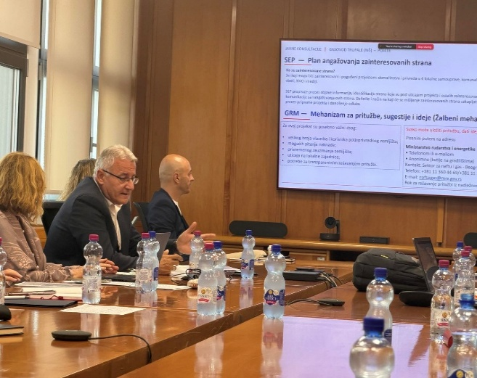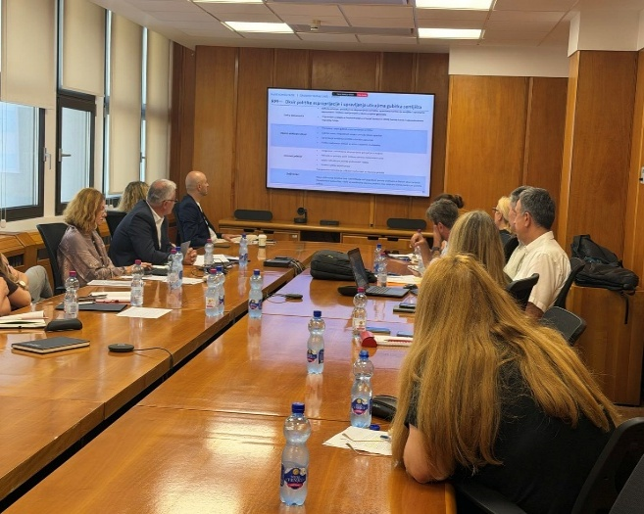
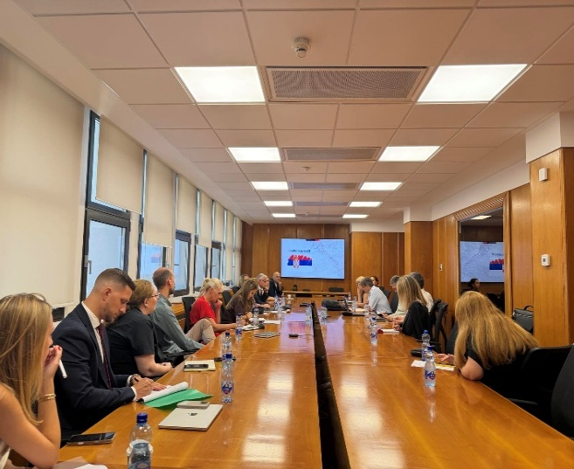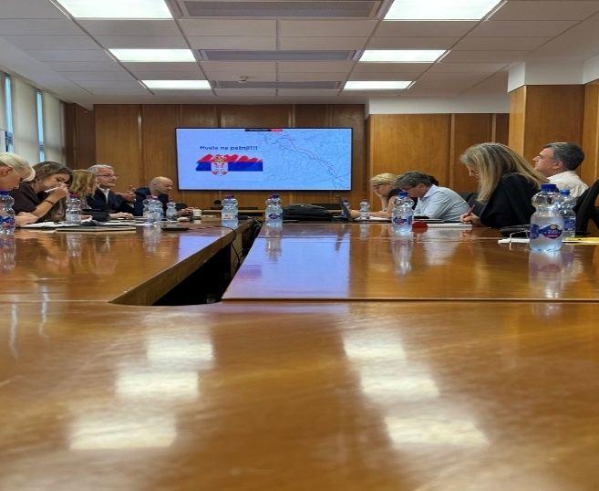

Aleksinac, 12 August 2026
Public consultations and presentation of the draft SR, RPF, SEP and ESCP documents with stakeholders were held in Aleksinac on 12 August 2026, at the premises of the Municipal Administration of the Municipality of Aleksinac, 169 Knjaza Miloša Street, in the Assembly Hall, commencing at 10:00 a.m.
The meeting was attended by representatives of the Ministry of Mining and Energy, the Municipality of Aleksinac, PUC “Water Supply and Sewerage”, the Public Roads Administration of Aleksinac, as well as other interested stakeholders.
The public consultations, organized in the form of a round-table discussion, commenced as scheduled at 10:00 a.m.
A total of 23 participants attended the public consultations:

List of participants present, Aleksinac, 12 August 2026
No. | Name and surname | Institution
1. | Saša Koković | MоME
2. | Snežana Ristić | MоME
3. | Nikola Pančić | Municipal Administration Aleksinac
4. | Anita Nedeljković | Municipal Administration Aleksinac
5. | Jovan Stojanović | Municipal Administration Aleksinac
6. | Milena Matić | PUC „Vodovod i kanalizacija“
7. | Jovan Djordjević | Municipal Administration Aleksinac
8. | Novica Dragičević | Public Enterprise for Roads and SKD
9. | Tamara Klain | Municipal Administration Aleksinac
10. | Anastasija Djordjević | Municipal Administration Aleksinac
11. | Sanja Ganić | Municipal Administration Aleksinac
12. | Uros Dimitrijević | Public Utility Company for Roads of Aleksinac
13. | Vladimir Nikodijević | Municipal Administration Aleksinac
14. | Emilijan Milosavljević | Institution „Lipovac“
15. | Aleksandra Milovanović | Institution „Lipovac“
16. | Branislav Ančević | Cultural Centre
17. | Ivan Markovic | Utility Services PUC
18. | Vuk Radisavljević | Cultural Centre
19. | Mia Tomić | Center for Social Work Aleksinac
20. | Natalija Milenković | Center for Social Work Aleksinac
21. | Živomir Ivkovic | Village Rutevac
22. | Natalija Luković | MоME
23. | Minuška Stojanović | Municipal Administration Aleksinac

Questions and Answers
Vladimir Nikodijević, Environmental Protection Advisor at the Municipal Administration of Aleksinac, emphasized that there are no facilities within the municipality that would be significantly affected by the implementation of the project. He noted that, for certain locations, it will be necessary to obtain conditions and approvals from the competent nature protection authorities. He also pointed out that it is a positive aspect that the planned route bypasses the Deligrad area. In particular, he stressed that the greatest challenge for project implementation will be property-related issues and expropriation procedures, which may affect the project implementation schedule.
Jovan Stojanović from the Department of Urban Planning asked questions regarding the project implementation schedule and the timeframe for initiating the expropriation process. Representatives of the Ministry explained that the project is currently in its initial preparation phase and that the preparation of the documentation required for World Bank approval is underway, after which the development of the detailed design and technical documentation will follow. It was stated that the commencement of field activities is not expected before September 2027.
Sasa Koković emphasized that the local self-government will be informed in a timely manner about all subsequent project steps and activities. He also noted that issues related to the future ownership and operation of the gas pipeline system will be clarified during the further preparation of the project. In addition, it was stated that activities related to expropriation are expected to commence in late 2028.
In the continuation of the discussion, Jovan Stojanović raised the issue of road rehabilitation after gas pipeline works. Project representatives explained that all activities are implemented in accordance with applicable regulations, including the obligation to restore infrastructure to an appropriate condition, as well as the possibility to submit comments if irregularities are identified.
Minuška Stojanović, public relations representative of the Municipality of Aleksinac, asked about the method of informing citizens and the locations where project information would be available. It was answered that public information activities would be coordinated by the project team, and that the current phase is primarily focused on preparatory activities and familiarizing stakeholders with the project.
Summary of public consultations
Participants agreed that continuous cooperation between the project team and the local self-government is of key importance for successful project preparation. The need for timely delivery of accurate data necessary for design and planning of further activities was particularly emphasized, as was the continuation of regular communication throughout all phases of project preparation.

Figure 5: Public consultations, Aleksinac, 12 August 2026

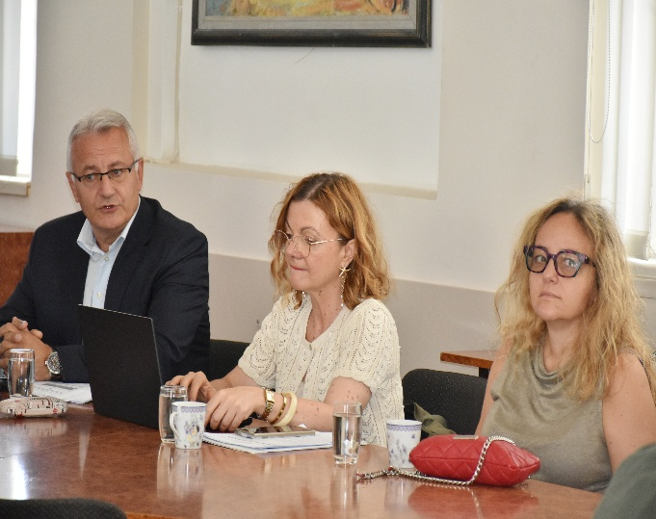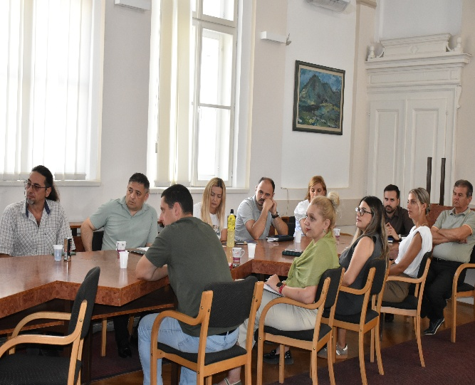

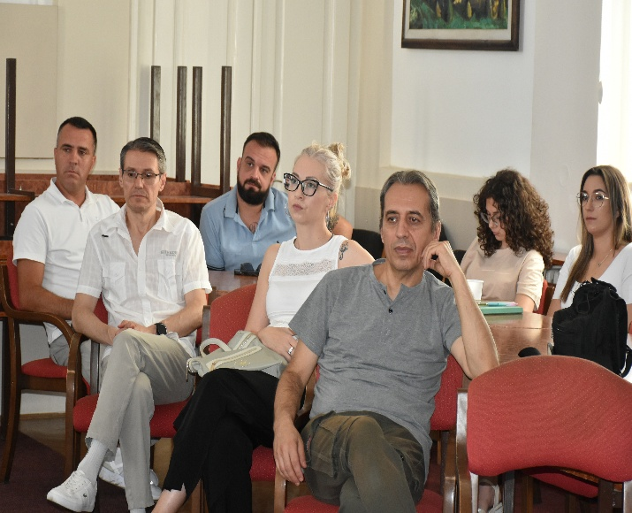

Niš, 12. avgust 2026. godine
Public consultations and presentation of the draft SR, RPF, SEP and ESCP documents to stakeholders were held in Nis on 12 August 2026, in the Office of the Mayor of the City of Nis, 7. juli Street No. 2, Nis, starting at 13:00.
The meeting was attended by representatives of the Ministry of Mining and Energy, the PE Directorate, the PUC Parking Service, the Chief Urban Planner of the City of Niš, as well as other interested stakeholders.
The public consultations, held in the form of a round-table discussion, commenced as scheduled at 1:00 p.m.
A total of 19 participants attended the public consultations:
List of participants present, Nis, 12 August 2026
No. | Name and surname | Institution
1. | Saša Koković | MоME
2. | Snežana Ristić | MоME
3. | Veljko Tomić | JP Direkcija
4. | Lidija Stefanovic Nikolić | Glavni urbanista City ofa Nisa
5. | Aleksandar Milosević | PUC Parking servis
6. | Nenad Hafner | PUC „Gorica“
7. | Irena Stamenković | PUC „Mediana“ Nis
8. | Ivica Stojanović | PUC „Trznica“ Nis
9. | Jelena Milovanović
10. | Gordana Ristić | Protokol City ofa
11. | Aleksandar Utvić | PUC Direkcija za javni prevoz
12. | Predrag Milačić | PUC Objedinjena naplata
13. | Živojin Tasić | PUC City ofska toplana
14. | Milan Milosavljević | JP Zavod za urbanizam
15. | Goran Stojković | PUC Direkcija JGP
16. | Ivan Grmuša | Clan gradskog veca -City of Nis
17. | Darko Dejović | City Administration for Planning and Construction
18. | Goran Milanovic | GSA
19. | Natalija Luković | MоME

Summary of public consultations
No questions were asked by the participants present at the public consultations held in Nis.
Figure 6. Public consultations, Nis, 12 August 2026
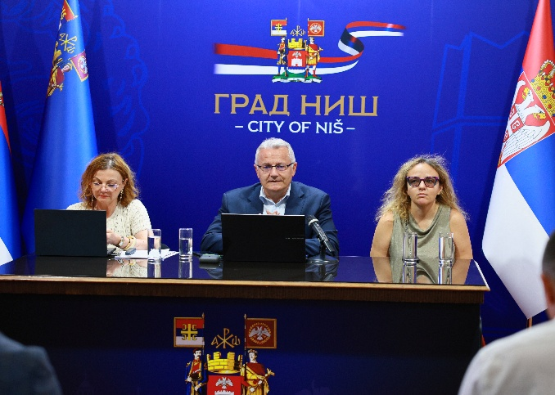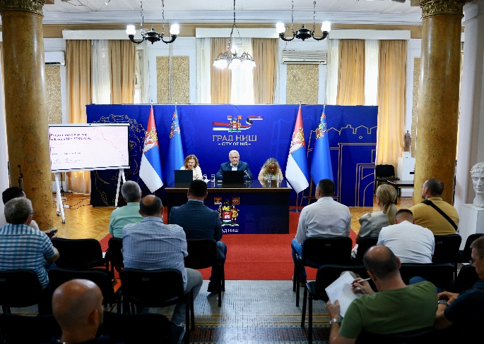
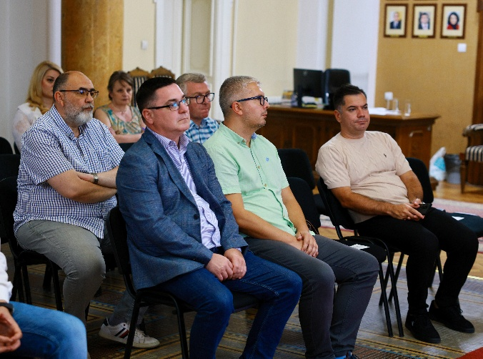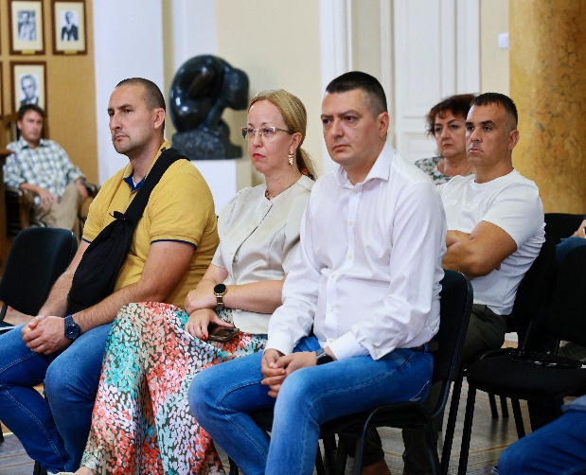

Ćicevac, 13 August 2026
Public consultations and presentation of the draft SR, RPF, SEP and ESCP documents to stakeholders were held in Ćićevac on 13 August 2026 at the premises of the Cicevac Municipal Assembly, Karadjordjeva 106, Ćićevac, starting at 10:00.

The meeting was attended by representatives of the Ministry of Mining and Energy, the Municipality of Ćićevac, as well as other interested stakeholders.
The public consultations, held in the form of a round-table discussion, commenced as scheduled at 10:00 a.m.
A total of 16 participants attended the public consultations:
List of participants present, Ćićevac, 13 August 2026
No. | Name and surname | Institution
1. | Saša Koković | MоME
2. | Snežana Ristić | MоME
3. | Milos Radosavljevicć | Municipality of Cicevac
4. | Zoran Andjelković | Municipality of Cicevac
5. | Marija Bodic | Municipality of Cicevac
6. | Zvezdan Gacić | -
7. | Aleksandar Šukić | OS „Dositej Obradovic“
8. | Jovica Bogdanović | Municipality of Cicevac
9. | Aleksandra Krkić | Municipality of Cicevac
10. | Snežana Milutinović | Municipality of Cicevac
11. | Milan Ivanović | Municipality of Cicevac
12. | Jelena Nastić | Municipality of Cicevac
13. | Dragana Jeremić | Municipality of Cicevac
14. | Vesna Pantić | Municipal Administration
15. | Aleksandar Stojanović | PE Roads Cicevac
16. | Života Milovanović | PE Roads Cicevac

Questions and answers:
At the public consultations in Ćićevac, issues were discussed relating to the planned gas pipeline route, its position in relation to the existing Yugorosgaz route, the extension of the protection zone, and the need to harmonize the local self-government planning documentation.
Snežana Milutinovic, Urban Planning Section, asked whether the gas pipeline route is known.
It was clarified that the route would run parallel to the existing Yugorosgaz pipeline route, at an approximate distance of two meters, which would require an extension of the safety (protection) corridor.
Jovica Bogdanović, Urban Planning Department, pointed out the need to harmonize the planning documents and noted that no funding has been secured for this purpose.
It was concluded that the issue of insufficient financial and human resources should be recorded as an open issue requiring further coordination.

Summary of public consultations
Participants were informed about the indicative approach to route alignment and the need for further elaboration through planning and technical documentation. Limited human and financial capacities of the local self-government for harmonizing planning documents were identified as a key open issue; therefore, in the next steps, possibilities for support and clear definition of the obligations of all participants should be considered.

Figure 7. Ražanj, 13 August 2026
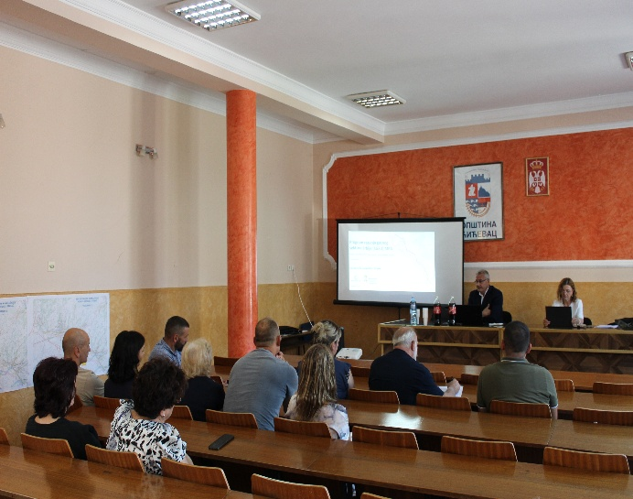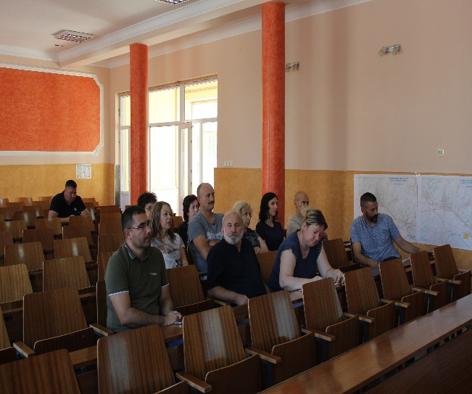
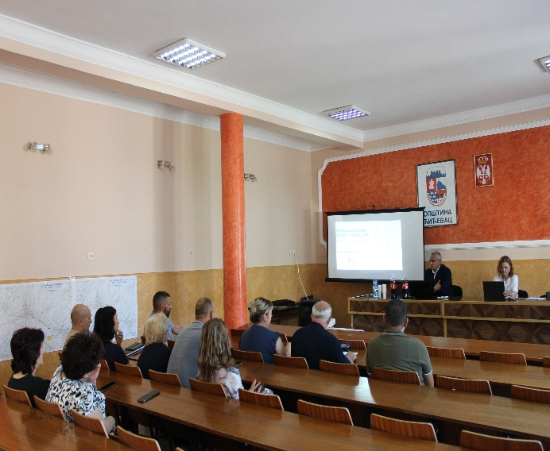

Ražanj, 13 August 2026
Public consultations and presentation of the draft SR, RPF, SEP and ESCP documents with stakeholders were held in Ražanj on 13 August 2026 at the premises of the Municipality of Ražanj, Small Hall, 33 Trg Svetog Save, Ražanj, commencing at 1:00 p.m.
The meeting was attended by representatives of the Ministry of Mining and Energy, the Municipality of Ražanj, the Mađere Local Community (MZ Mađere), as well as other interested stakeholders.
The public consultations, held in the form of a round-table discussion, commenced as scheduled at 1:00 p.m.

A total of 20 participants attended the public consultations.

List of participants present, Razanj, 13 August 2026
No. | Name and surname | Institution
1. | Saša Koković | MоME
2. | Snežana Ristić | MоME
3. | Aleksandar Drenić | Municipal Administration Razanj
4. | Marija Vujić | Municipal Administration Razanj
5. | Renata Bajkić | Municipal Administration Razanj
6. | Jovana Nedeljković | USR Razanj
7. | Milena Marković | Preschool Institution "Leptirici" Razanj
8. | Marija Andjelković | Preschool Institution "Leptirici" Razanj
9. | Marijana Stanković | PE Roads Razanj
10. | Svetlana Janosevic Pešić | Municipal Administration Razanj
11. | Marija Ranić | Municipal Administration Razanj
12. | Dejan Gagić | Local Community Madjere
13. | Nemanja Milenović | Local Community Setka
14. | Anica Majašević | Municipal Administration Razanj
15. | Marija Slavković | Local Community Madjere
16. | Ljubodrag Pešić | Local Community Praskovce
17. | Darko Ružić | Municipal Administration Razanj
18. | Ana Todorović | Municipal Administration Razanj
19. | Aleksandra Nikodijević | Citizens Association "Suncev zrak"
20. | Sandra Simić | Municipal Administration Razanj

Questions and Answers

At the public consultations held in Ražanj, questions were raised regarding expropriation timelines, phases of planning documentation, the possibility of connection to and expansion of the distribution network, protection of local roads during construction works, the position of the route in relation to the water source, and safety aspects arising from the proximity of two gas pipelines.
Svetlana Janošević Pešić from the Municipal Administration inquired about the timeline for expropriation. It was explained that the exact timeframe would be determined after the route alignment, conceptual design, cadastral parcels, and property-rights issues have been defined, and that expropriation activities are not expected to commence before 2028.
It was further stated that the preparation of planning documentation would follow the consultations. The decision to prepare the Spatial Plan was adopted in 2024, after which the preparation of the Detailed Regulation Plan will proceed.Participants pointed out the risk of damage to local roads during works, as well as previous experiences after gas pipeline construction.
Marija Anđelković asked about the possibilities for network expansion and new connections. The difference between the transmission system and the distribution system was explained, and it was noted that an assessment of potential connections could be submitted to the Ministry for onward transmission to Yugorosgaz.
A question was raised concerning the route in relation to the water source for the MZ Madjere local community, and it was proposed that relevant data on the water source be submitted.
The municipal inspector for environmental protection asked a safety question regarding the distance of two meters. An explanation was provided on the method of construction and protection of the gas pipeline, with the assessment that the probability of an accident on one gas pipeline endangering the other is very low.

Figure 8. Public consultations, Razanj, 13. avgust 2026. godine
